## GIT EXERCISE 3:

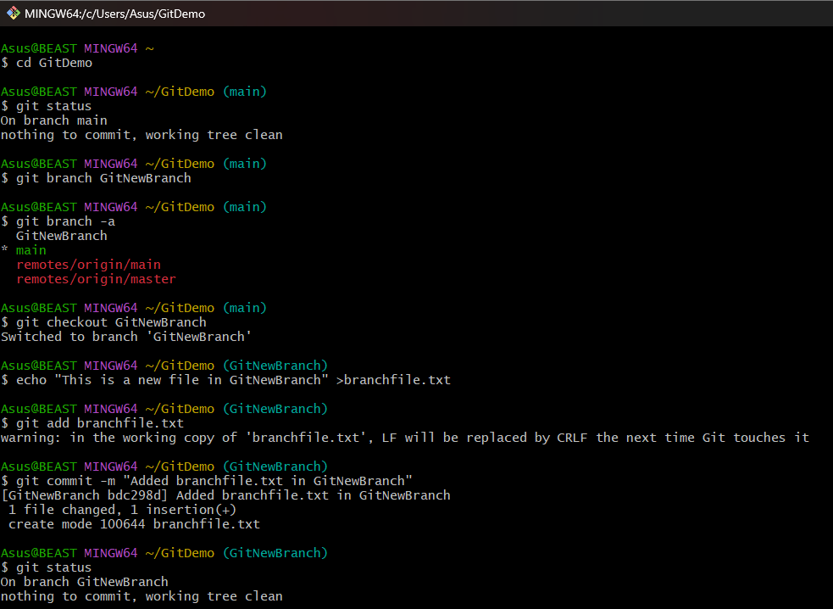

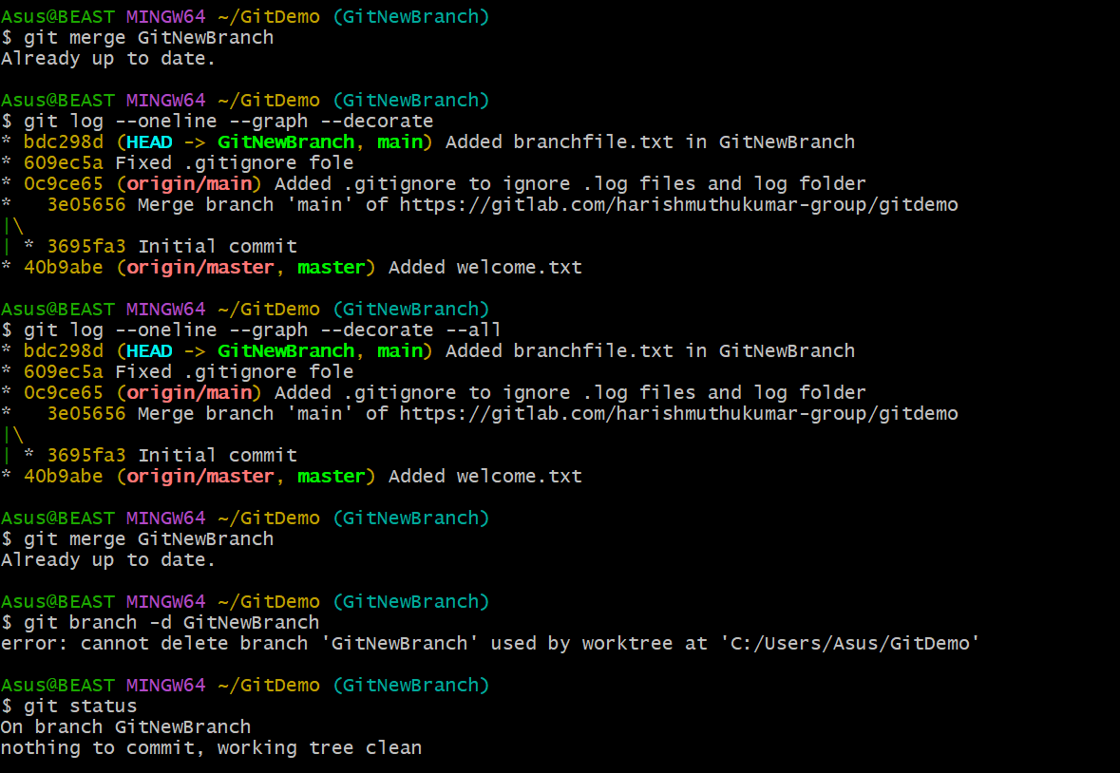

**Objectives:**

**Branching in Git**  
Branching is the process of creating a separate line of development in a repository. It allows you to work on new features, bug fixes, or experiments independently from the main codebase without affecting it. The default branch is often called main or master. Developers can create new branches to isolate their work, and later merge them back once the changes are ready.

**Merging in Git**  
Merging is the process of integrating changes from one branch into another. When a feature branch is complete, it can be merged into the main branch. Git will automatically combine the changes if there are no conflicts; otherwise, conflicts must be resolved manually.

**Creating a Branch in GitLab**

1. Go to your GitLab project.
2. Navigate to **Repository → Branches**.
3. Click **New branch**.
4. Enter a branch name and choose the source branch (usually main).
5. Click **Create branch**.

**Creating a Merge Request in GitLab**

1. Go to your GitLab project.
2. Navigate to **Merge Requests → New merge request**.
3. Select the **source branch** (the branch you want to merge) and the **target branch** (where you want the changes to go, usually main).
4. Click **Compare branches and continue**.
5. Fill in the title and description for the merge request.
6. Assign reviewers if needed.
7. Click **Create merge request**.